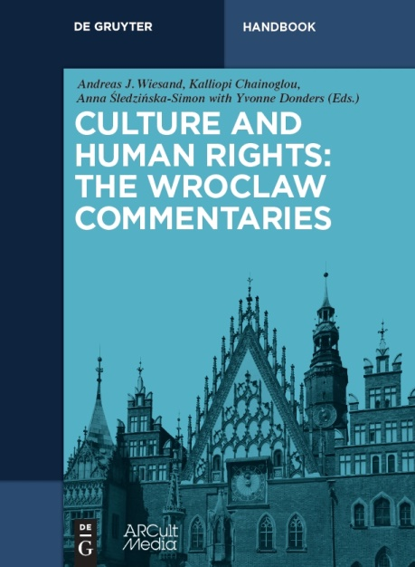
CULTURE AND HUMAN RIGHTS:
THE WROCLAW COMMENTARIES
Editors: Andreas Joh. Wiesand, Kalliopi Chainoglou and
Anna Śledzińska-Simon in collaboration with Yvonne Donders

De Gruyter, Berlin/Boston and ARCult Media, Cologne 2016,
360 pages, EUR 99,95 / US $110 / £80
Hardcover: ISBN 978-3-11-044050-8
e-book – PDF: 978-3-11-043225-1
e-book – EPUB: 978-3-11-043236-7
- The basic guide to human rights issues in the wider domain of “culture”
- 7 overview articles and 123 keyword entries, written by 96 experts
- Developed by ARCult Media in the context of Wrocław – European Capital of Culture 2016
Under the patronage of:
Gabriella Battaini-Dragoni, Deputy Secretary General of the Council of Europe;
Gerhart Rudolf Baum, Human rights lawyer and former German Minister of the Interior (in charge of culture); Rafał Dutkiewicz, Mayor of the City of Wrocław;
Farida Shaheed, UN Special Rapporteur in the field of cultural rights, 2009-2015
Scientific Committee:
- Yvonne Donders (Amsterdam, Chair)
- Heiner Bielefeldt (Erlangen)
- Janet Blake (Tehran)
- Paul de Hert (Brussels/Tilburg)
- Andrzej Jakubowski (Warsaw)
- Annamari Laaksonen (Sydney)
- Federico Lenzerini (Siena/Miami)
The new handbook addresses legal questions and political consequences related to safeguarding human rights and cultural diversity, including freedom of, or access to, the arts, heritage and (old/new) media, questions of religious and language rights, the protection of minorities and other vulnerable groups, and many more issues.
Specialists from all over Europe and the world summarise and comment on core messages of legal instruments, the essence of case-law as well as prevailing and important dissenting opinions in the literature, with the aim of providing a user-friendly tool for the daily needs of decision or law-makers at different juridical, administrative and political levels as well as others working in the field of culture and human rights.
[ Order ]

